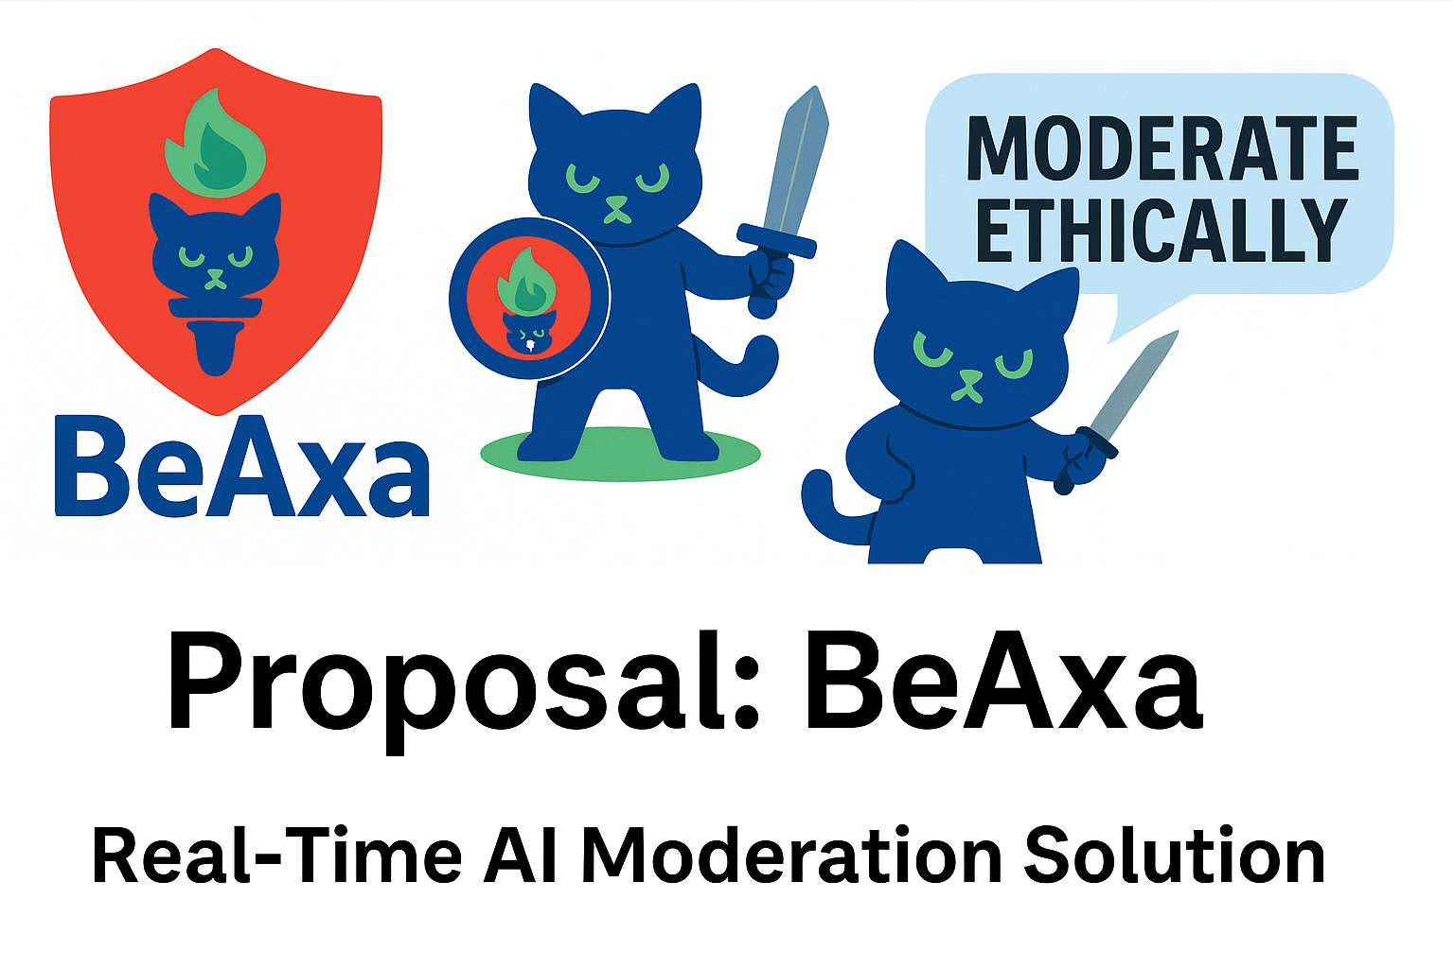
1. Project Overview
1.1 Project BeAxa (BA) is a GroupBuild-led initiative to develop a modular, cross-checking AI stack that acts as a real-time ethical moderator for user-generated content. Initially, BeAxa will be designed for user by GroupBuild, but subsequently it will be offered to other open-source social platforms. To summarize, BeAxa will:
- Evaluate posts for misinformation and unethical rhetoric
- Tag posts in almost real-time using colored markup scheme
- Illustrate each post's levels of unethical, irrational or contradictory content
- Flag potential bots, infiltrators, or manipulative actors
- Warn users about identity-revealing content
- Respect anonymity via the GroupBuild AnonID system
- Support multiple AnonIDs per user without linkage
- Provide advanced search, sort, and filtering capabilities
- Enforce both platform-wide and Group-specific content policies
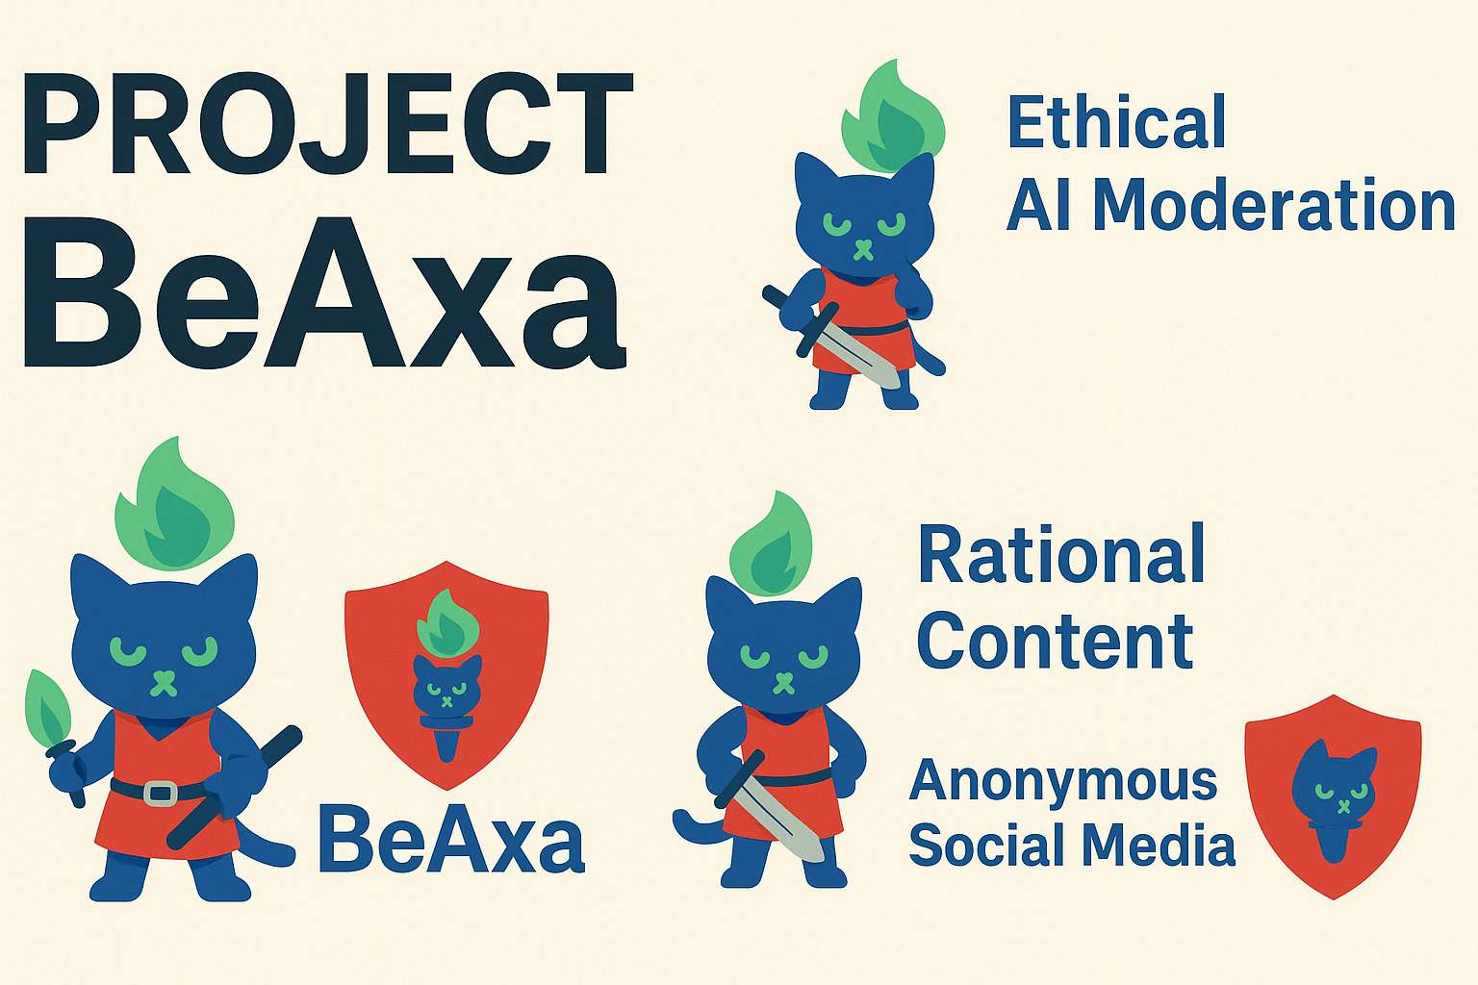
1.2 BeAxa is also envisioned as a license-able product that can be integrated into GroupBuild, and third-party civic tech or federated social media platforms, providing automated moderation and trust-layer services while protecting user anonymity.
1.3 BeAxa will also need a also envisioned as a license-able product that can be integrated into GroupBuild, and third-party civic tech or federated social media platforms, providing automated moderation and trust-layer services while protecting user anonymity.

2. Functional Capabilities
2.1 Post Moderation
- Detects and tags misinformation, recycled propaganda, and anti-scientific claims
- Highlights irrational language, inconsistent logic, and ethical red flags
- Tracks contradictions within the user’s own prior posts
2.2 AnonID & Identity Protection
- Flags identity-revealing phrases in real time and warns the user
- Ensures strict separation between different AnonIDs held by a single user
- No central identity resolution occurs unless explicitly permitted by the user
2.3 Bot & Infiltrator Detection
- Uses behavior analysis to detect bots and synthetic users
- Monitors for pattern-based manipulation and semantic mimicry
- Provides warnings and soft bans for suspicious accounts
2.4 Search, Sort, and Filter
- Allows users to filter or search by ethical reliability, topic, tone, factuality
- Supports moderation dashboards for Group leaders and auditors
2.5 Multi-Level Rule Enforcement
- Distinguishes between:
  - Platform-wide behavioral policies
  - Custom Group-level policies
- Tags each violation using schema-specific markers for transparency

3. System Architecture
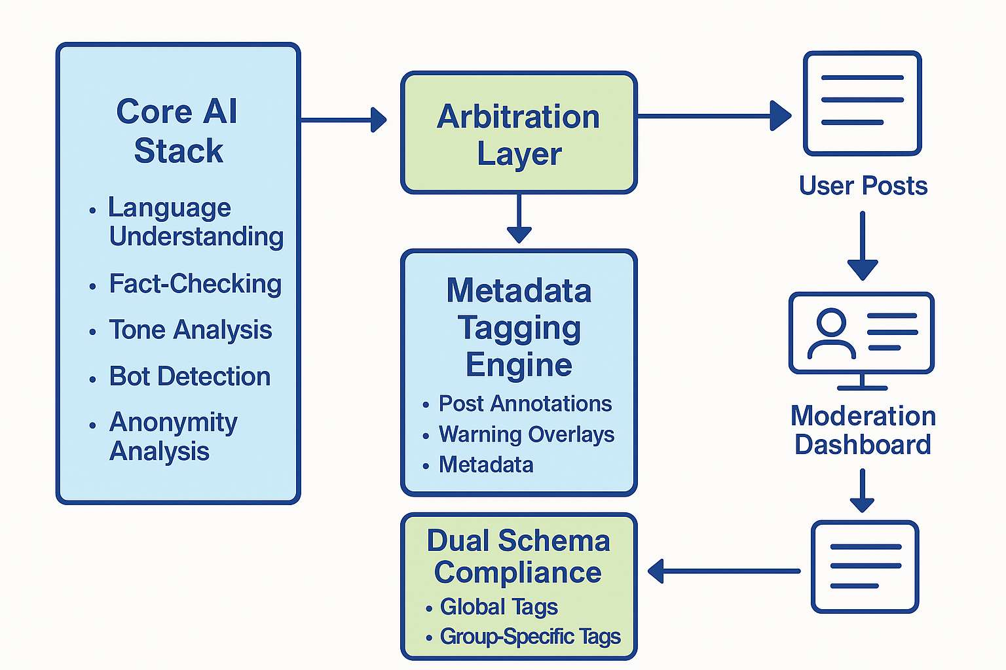
3.1 Core AI Stack
- Composed of repurposed modular models:
  - Language understanding (LLMs)
  - Fact-checking (retrieval-augmented generation)
  - Tone and sentiment analysis
  - Bot behavior detection
  - Anonymity analysis and redaction
3.2 Arbitration Layer
- A decision engine resolves conflicting signals between models
- Weighting preferences can be adjusted by Group policy
3.3 Metadata Tagging Engine
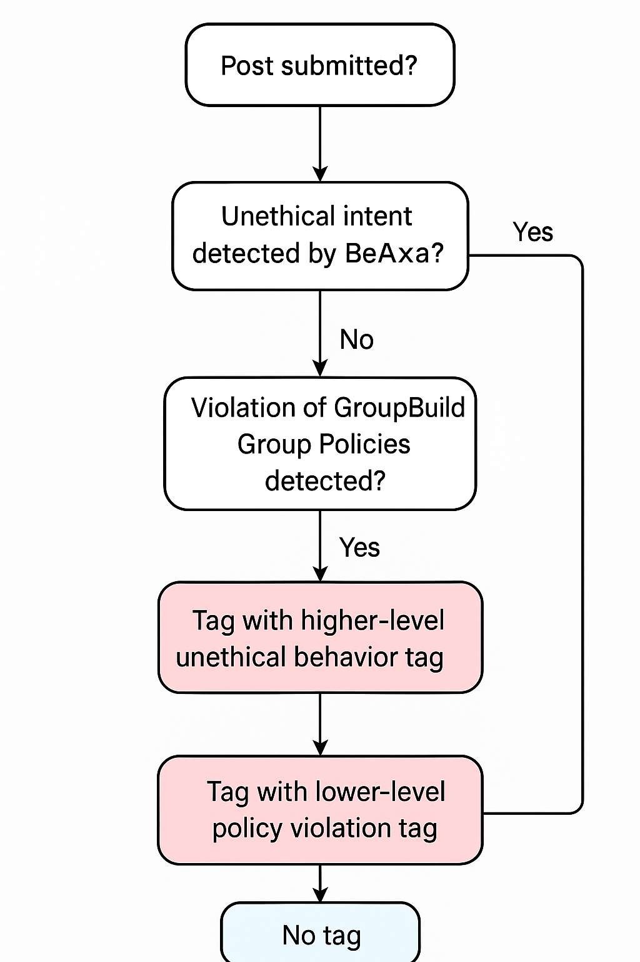
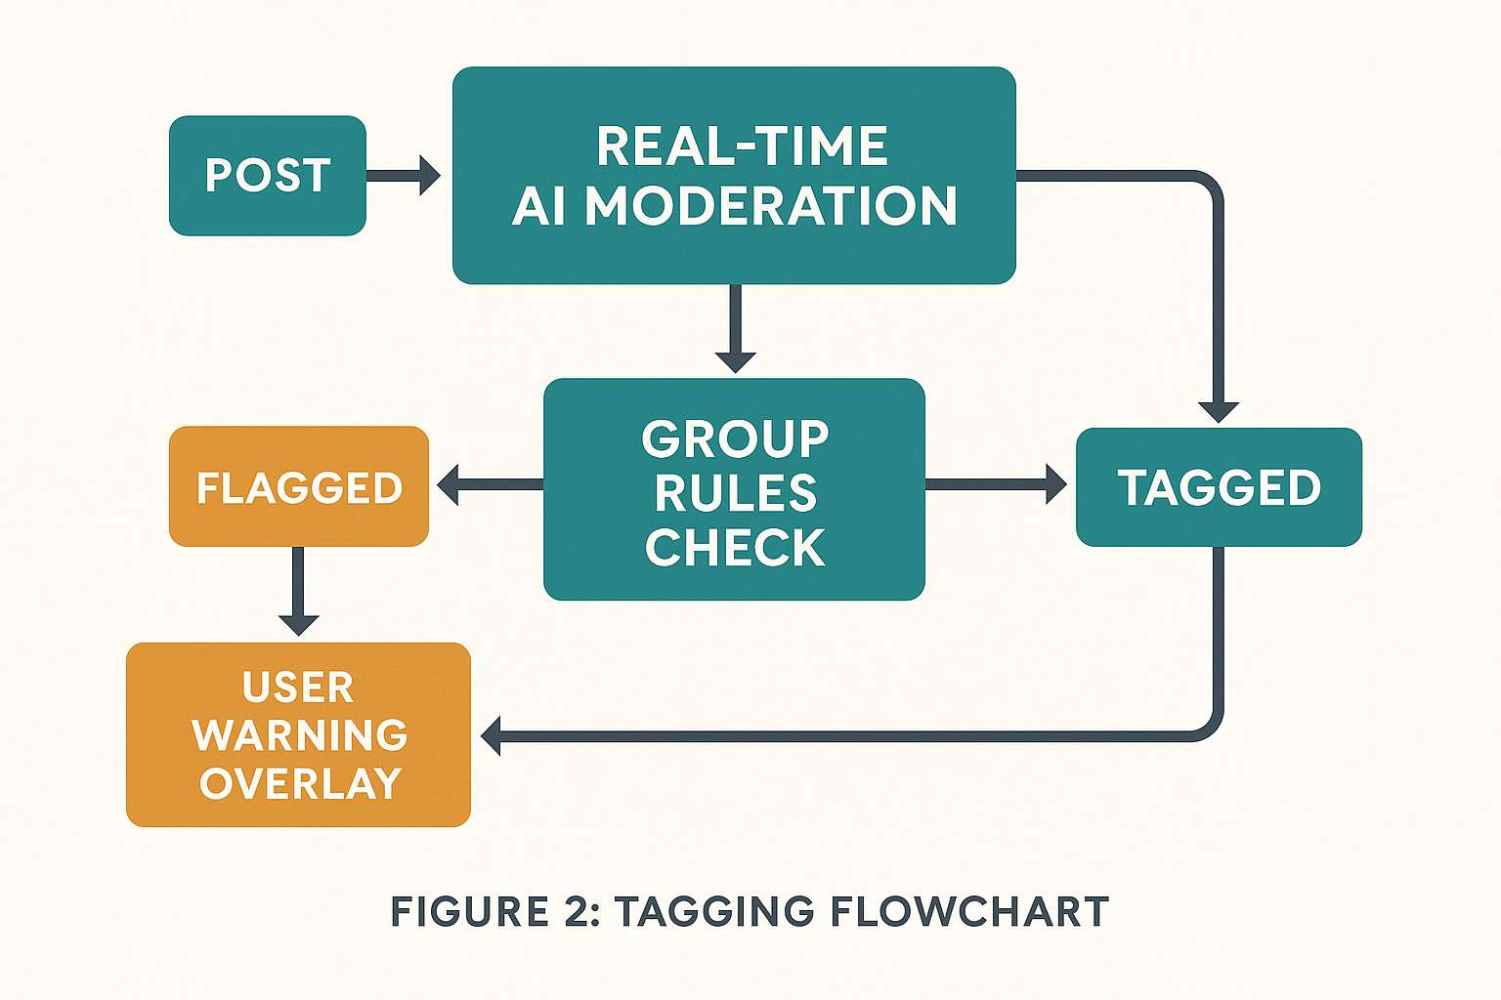
- Generates real-time post annotations with:
  - Probabilities of ethical breach
  - Warning overlays and inline flags
  - Metadata for sort/filter interfaces
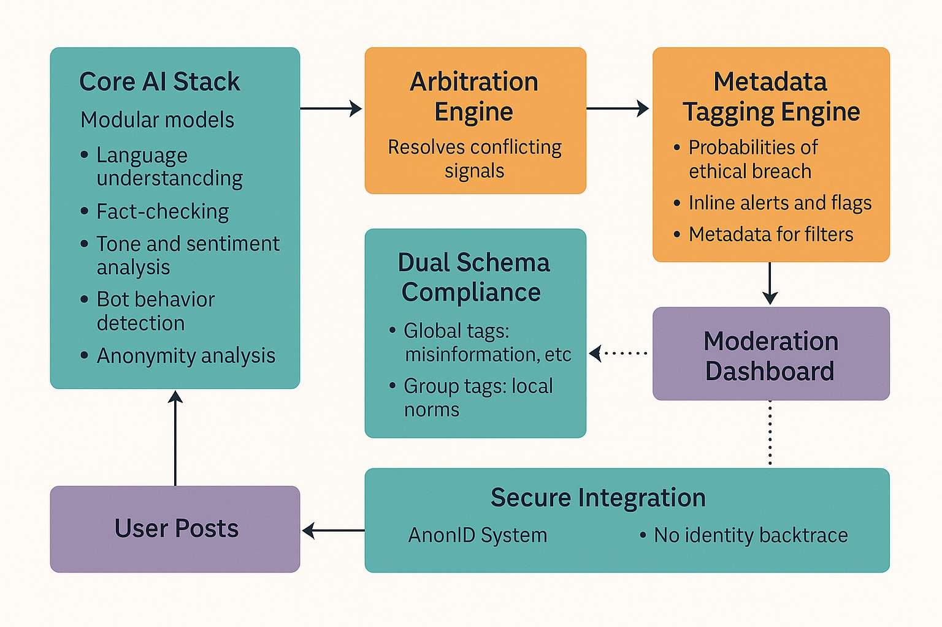
3.4 Dual Schema Compliance
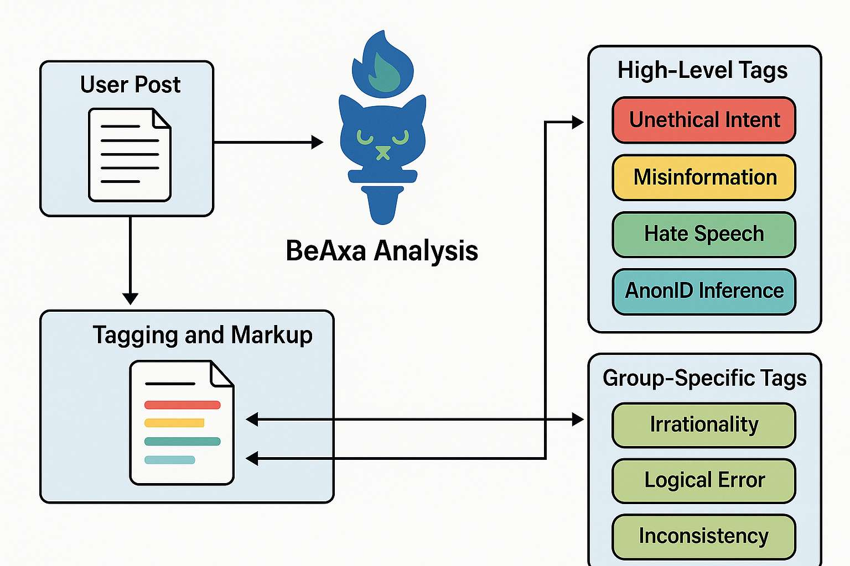
- Global tags: misinformation, hate speech, AI manipulation, etc.
- Group-specific tags: localized norms or conduct violations
3.5 Secure Integration with GroupBuild
- Built to interact with the GroupBuild AnonID identity layer
- Data storage uses hashed AnonID references with no identity backtrace

4. Vendor Services & Budget
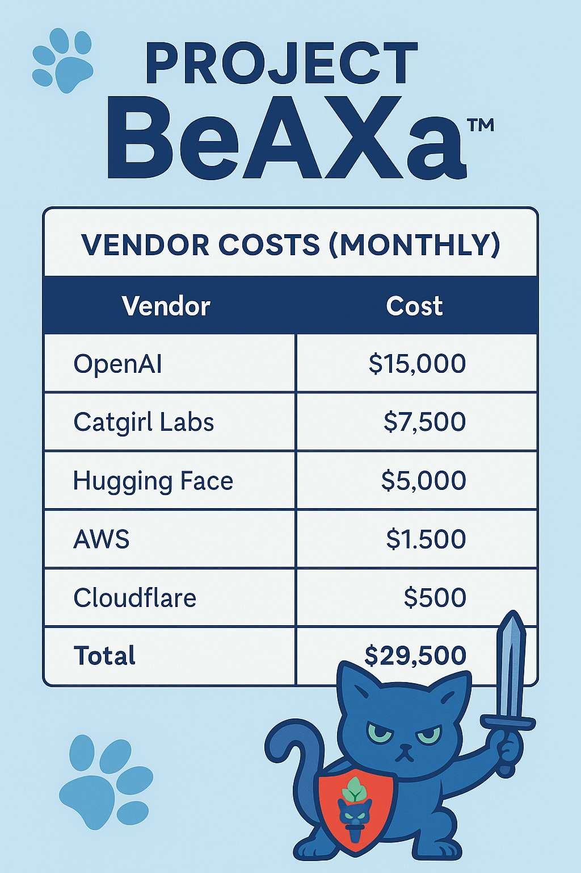
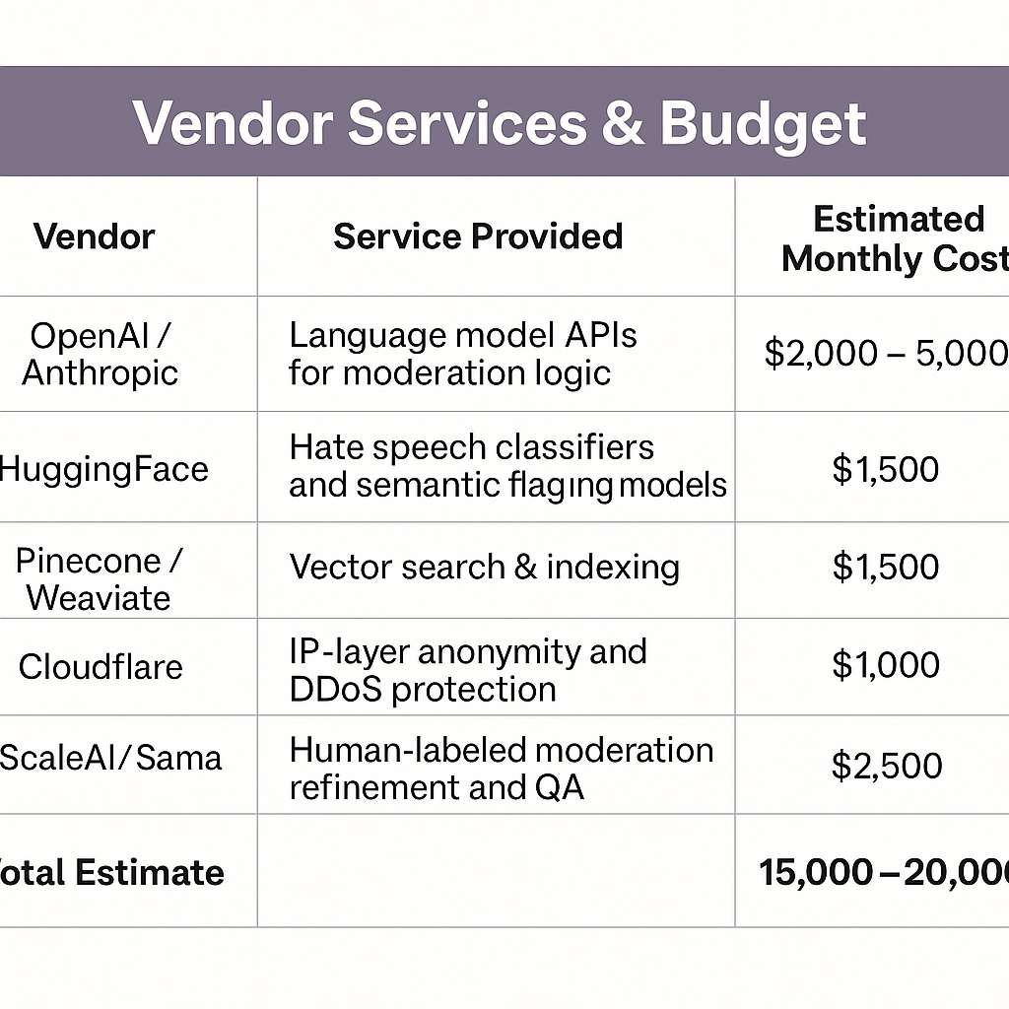
4.1 Suggested Vendors
Vendor | Service Provided
OpenAI / Anthropic | Language model APIs for moderation logic
HuggingFace | Pre-trained moderation + hate speech models
Pinecone / Weaviate | Vector search infrastructure for post indexing
Cloudflare | Anonymity and threat mitigation at the IP layer
ScaleAI / Sama | Human-audited model refinement and tagging tasks
4.2 Estimated Budget (Monthly)
- AI API access (usage-based): $2,000 – $5,000
- Infrastructure and database costs: $1,500
- Development and maintenance (3-person team): $10,000+
- Support + partner integration costs: $2,000
- Total Operating Estimate: $15,000 – $20,000 / month

5. Implementation Roadmap
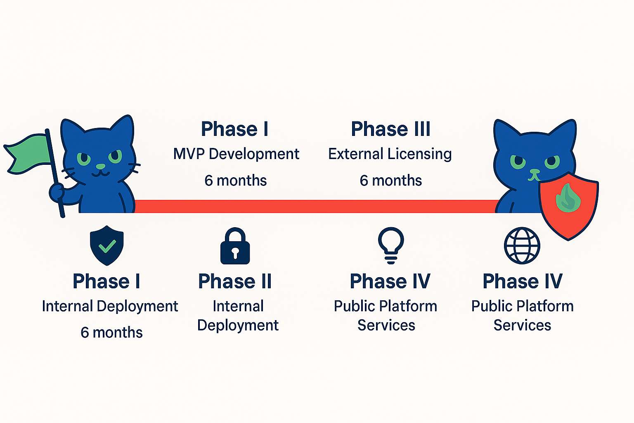
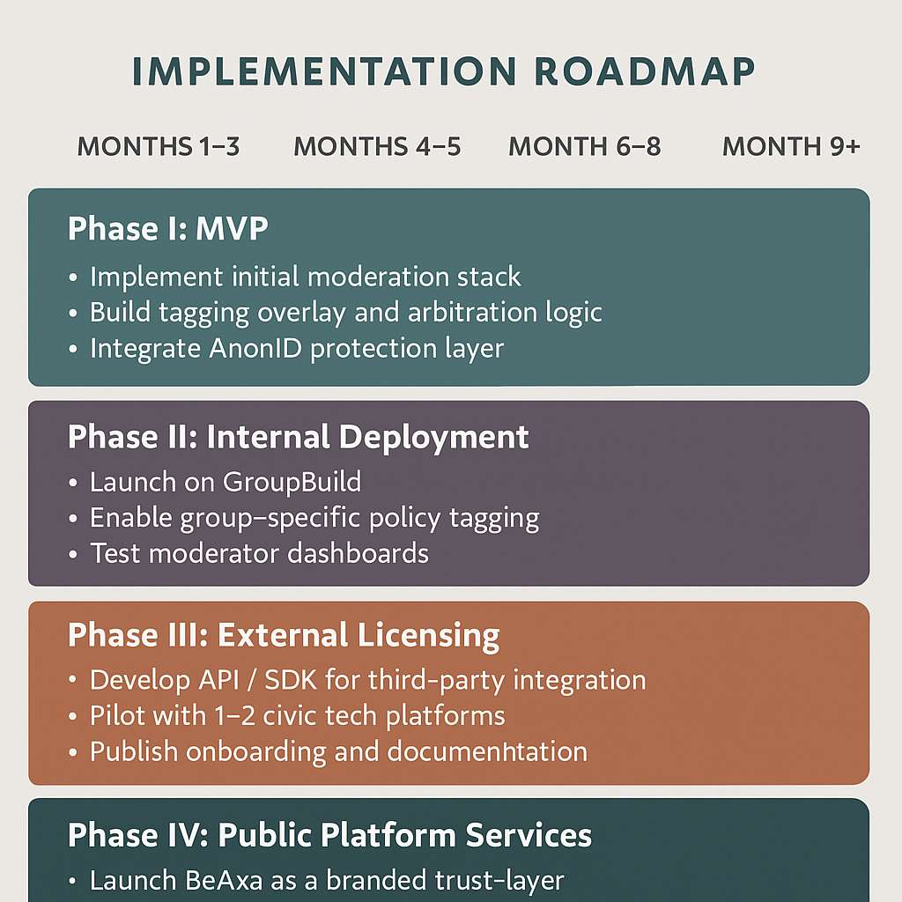
5.1 Phase I: MVP (Month 1–3)
- Implement core moderation models
- Build initial tagging overlay
- Integrate with AnonID identity layer
5.2 Phase II: Internal Deployment (Month 4–5)
- Deploy on GroupBuild’s platform
- Begin Group-level rules integration
- Test moderation dashboards
5.3 Phase III: External Licensing (Month 6–8)
- API and SDK development
- Pilot licensing with 1–2 external platforms
- Create onboarding and support docs
5.4 Phase IV: Public Platform Services (Month 9+)
- Launch BeAxa as a branded moderation service
- Expand licensing with usage-based pricing tiers
- Maintain open-source portions for trust and adoption

6. Branding & Marketing Strategy
6.1 Mascot & Visual Identity
- BeAxa is represented by a cute yet determined warrior kitten, wearing light armor and wielding a small sword or torch.
- Visuals communicate a balance of protectiveness and charm, making the moderation function feel collaborative rather than punitive.
6.2 Marketing Position
- "BeAxa helps good conversations stay good."
- Promoted as a guardian of civil digital spaces — lightweight, pseudonymous, fast, and fair.
6.3 Sales Channels
- Civic tech communities
- Federated platforms like Mastodon, Lemmy, Kbin
- Privacy-first forums, whistleblower spaces
- Educational platforms seeking trust-building tools

7. Transparency & Trust Enhancements
To increase adoption and align with the principles of open civic tech, BeAxa will include a layered trust and explainability system.

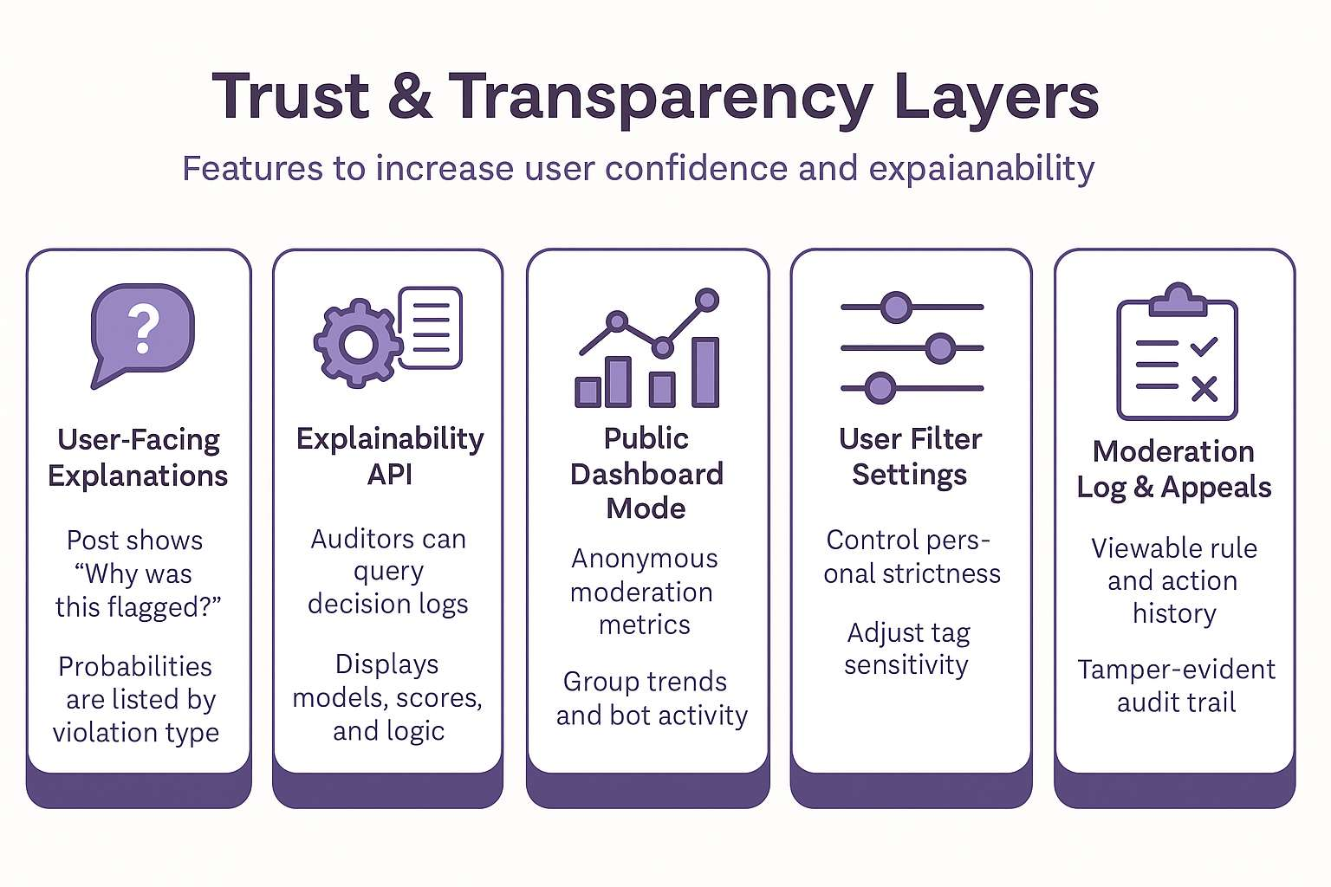
7.1 User-Facing Explanations
- Each flagged post shows a “Why was this flagged?” button
- Users see the probability per violation (e.g., 74% hate speech, 52% bot behavior)
- Optional “I disagree — here’s why” feedback loop

7.2 Explainability API
- External auditors can query how decisions were made
- Arbitration logs list:
  - Involved models
  - Weightings used
  - Final override logic

7.3 Public Dashboard Mode
- Anonymous heatmaps of moderation data
- Live trends in Group violations or bot activity
- No individual posts or identities are shown

7.4 User Filter Settings
- Optional controls to let users/members:
  - Adjust moderation strictness
  - Toggle sensitivity for irony or sarcasm
  - Ignore low-severity tags

7.5 Moderation Log & Appeals
- All post actions are logged in a tamper-evident audit trail
- Users may view:
  - Rule broken
  - Group-specific modifiers
  - Moderator override if applicable
- Groups can offer appeals or trust votes to revise moderation decisions

